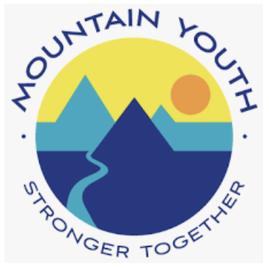
Permission Slip and Waiver of Liability

Participant (Please Print): _______________________________________ Age: _____ Pronouns: ____

Mailing Address: ________________________________________________________________

Date of Birth: _______________ Phone: ___________________ Email: _____________________

I give my permission for my child ___________________________ to participate in all activities related to Mountain Youth’s “He(art) of Vail Valley’s Youth” event, including but not limited to display of artwork or performance and participation in community speakers’ interactive art activities (if they are to attend the event in person or virtually). By signing this form, you agree to let Mountain Youth display your art as part of our event. Furthermore, Mountain Youth complies fully with COVID restrictions put in place by Eagle County, and by signing this form you understand that Mountain Youth cannot be held accountable for any health problems that may occur after the event due to one’s participation.

- I understand and acknowledge this release discharges Mountain Youth from any liability or claim that I may have against Mountain Youth with respect to displaying and/or advertising my artwork.

- I understand my participation in activities is purely voluntary and I elect to participate in spite of the risks due to COVID.

- I hereby certify that I am physically healthy and will stay home/not participate in this event if I become sick with any COVID symptoms.

- I hereby freely and expressly assume and accept the responsibility for any and all risks of injury or death while participating in this Mountain Youth event. I understand that Mountain Youth, its directors, officers, agents, employees, and volunteers (hereinafter “releasees”) do not assume any responsibility for or obligation to provide me with financial or other assistance, including but not limited to medical, health, or disability benefits or insurance of any nature in the event of injury, illness, death or damage to my property. I expressly waive any such claim for compensation or liability on the part of Mountain Youth beyond what may be offered freely by Mountain Youth in the event of such injury or medical expenses incurred by me.

- I agree that in the event of a medical emergency, Mountain Youth, its agents, employees, and volunteers may provide medical assistance deemed necessary under the circumstances. I further agree and authorize Mountain Youth, its agents, employees, and volunteers to make any and all necessary arrangements for emergency care and I agree that these parties shall be free from any liability to me or my heirs for personal injury or loss resulting from my transportation to a medical facility.

- I grant permission to Mountain Youth to use photographs, video, and audio taken of me for use in publications such as brochures, newsletters, reports and to use such images in electronic versions of the same publications or on websites or other electronic forms or media. I hereby waive any right to inspect or approve the finished photographs or printed or electronic matter that may be used in conjunction with them now of in the future, whether that use is known to me or unknown. I am not entitled to any compensation, payment, or royalties for their use and I understand that all materials will remain the property of Mountain Youth.

- I expressly agree that this release is intended to be as broad and inclusive as permitted by the laws of the State of Colorado and that this release shall be governed by and interpreted in accordance with the laws of the State of Colorado. I agree that in the event that any clause or provisions of this release is deemed invalid, the enforceability of the remaining provisions of this release shall not be affected.

- By signing below, I express my understanding and intent to enter into this release and waiver of liability willingly and voluntarily.

Signature (Participant): ___________________________________________ Date: ______________

Participant under 18 years of age: As parent/guardian signing this agreement for the above named minor, I acknowledge that I am authorized to sign this agreement for the minor. I acknowledge and agree that I have read the above release and that by signing this release on behalf of the minor, the minor and I agree to be bound by its terms. I hereby agree to indemnify, defend and hold harmless the releasees for any claim or suit arising out of said minor’s participation in Mountain Youth events.

Signature (Guardian): ____________________________________________ Date: ______________

Emergency Contact:
In case of an emergency, please contact:

Name: __________________________________________ Phone: ___________________________

Relationship: ____________________________________ Alternate Phone: _____________________

